NEXTAG COMPANY

**GG iPhone case with tiger print**

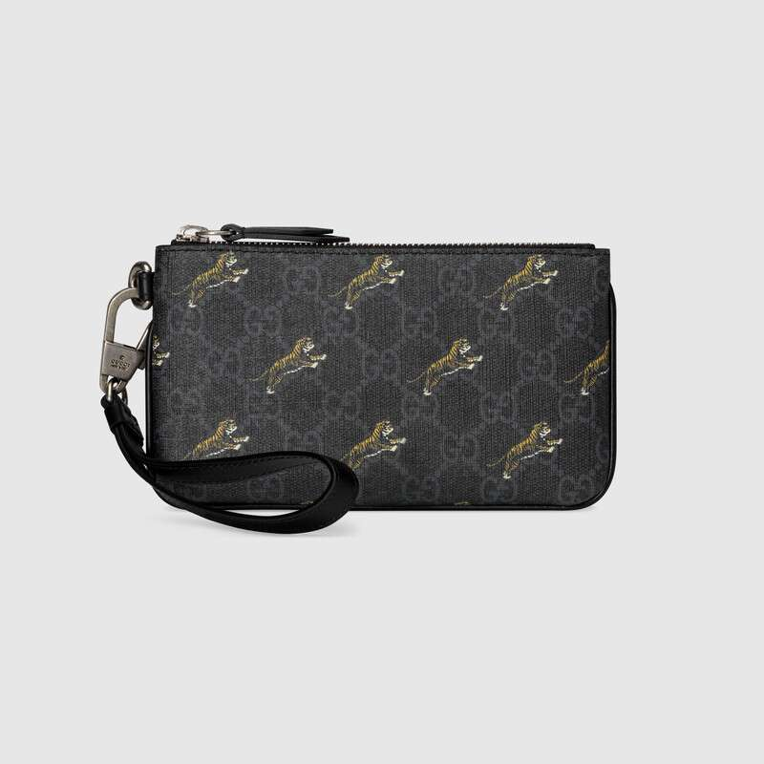

Style # 575137 G2BAN 1087

Product Description

Presented in black and grey GG Supreme canvas, this iPhone case is completed by a

removable wrist strap. Tigers, reflecting the fascination for wild animals that permeate

the House's narrative, contrast the monogrammed background.

Black leather trim • Removable wrist strap with 4.9" drop • Two card slots

• Zipper closure • Made in ItalyPresented in black and grey GG Supreme canvas, this iPhone case is completed by a removable wrist strap. Tigers, reflecting the fascination for wild animals that permeate the House's narrative, contrast the monogrammed background.

* Black/grey GG Supreme canvas with tigers print, a material with low environmental impact
* Black leather trim
* Moiré lining
* Two card slots
* Removable wrist strap with 4.9" drop
* Zipper closure
* 7"W x 4.3"H
* Made in Italy

Presented in black and grey GG Supreme canvas, this iPhone case is completed by a removable wrist strap. Tigers, reflecting the fascination for wild animals that permeate the House's narrative, contrast the monogrammed background.

* Black/grey GG Supreme canvas with tigers print, a material with low environmental impact
* Black leather trim
* Moiré lining
* Two card slots
* Removable wrist strap with 4.9" drop
* Zipper closure
* 7"W x 4.3"H
* Made in Italy
* PRODUCT DETAILS
* Style ‎575137 G2BAN 1087
* Presented in black and grey GG Supreme canvas, this iPhone case is completed by a removable wrist strap. Tigers, reflecting the fascination for wild animals that permeate the House's narrative, contrast the monogrammed background.
* Black/grey GG Supreme canvas with tigers print, a material with low environmental impact
* Black leather trim
* Moiré lining
* Two card slots
* Removable wrist strap with 4.9" drop
* Zipper closure
* 7"W x 4.3"H
* Made in Italy